IntelliSQL: Intelligent SQL Querying with LLMs Using Gemini Pro

Project Overview
IntelliSQL is an AI-powered web application designed to simplify database interaction by converting natural language queries into executable SQL commands. The system leverages Streamlit for the frontend interface and Google’s Gemini Pro (Generative AI model) for intelligent query generation.
In traditional database systems, users must possess strong knowledge of SQL syntax to retrieve information. Writing complex queries can be challenging for beginners and time-consuming even for experienced users. IntelliSQL eliminates this barrier by allowing users to interact with databases using simple English questions.
Instead of manually writing SQL statements, users can type queries such as:
- “Show all students who scored above 80 marks”
- “Find the average marks of students”
- “Display students from Data Science class”
The application processes the input using Natural Language Processing (NLP) and sends a structured prompt to the Gemini Pro model via API. The model interprets the user’s intent, generates an optimized SQL query, and returns it to the application. The generated query is then executed on a SQLite database, and the results are displayed instantly on the interface.
The system follows a streamlined workflow:
- User enters a natural language query in the Streamlit interface
- The input is sent to the backend
- A structured prompt is generated dynamically
- The prompt is forwarded to the Gemini Pro model via API
- The model generates the corresponding SQL query
- The query is executed on the SQLite database
- The results are displayed to the user
By combining Generative AI, NLP, and database management, IntelliSQL enhances query assistance, improves data exploration, and enables users to extract meaningful insights without requiring deep SQL expertise.
This project demonstrates the practical application of Large Language Models in transforming traditional database querying into an intelligent, user-friendly, and efficient experience.
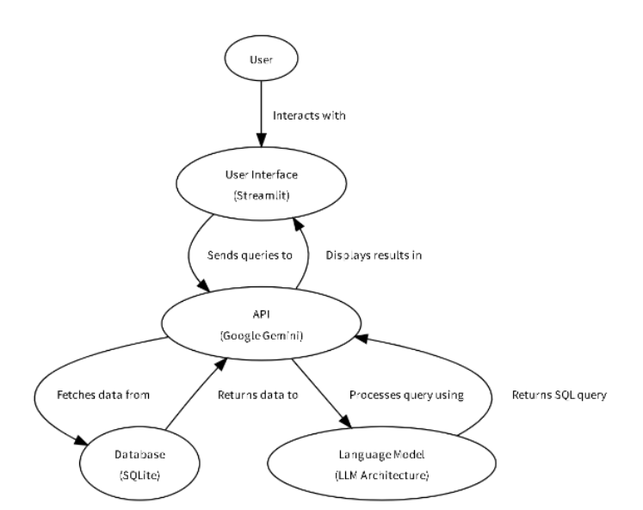
Architecture

1. User
The process begins with the User, who interacts with the system by entering a question in plain English, such as:
- “Show all students who scored above 80”
- “Find the average marks”
- “Display students from section A”
The user does not need prior knowledge of SQL.

2. User Interface (Streamlit)
The Streamlit UI acts as the presentation layer.
Responsibilities:
- Accepts natural language input
- Sends queries to the API layer
- Displays generated SQL query
- Shows database results
This layer ensures a simple, interactive, and real-time experience.
3. API Layer (Google Gemini API)
The API layer acts as the communication bridge between the frontend and the AI model.
Functions:
- Receives user query from Streamlit
- Generates a structured prompt
- Sends the prompt to Gemini Pro model
- Receives generated SQL query
- Returns SQL query to UI
This layer also handles secure API authentication using the Google API key.
4. Language Model (Gemini – LLM Architecture)
The Gemini Large Language Model is the core intelligence of IntelliSQL.
Responsibilities:
- Understands natural language input
- Interprets user intent
- Converts English query into valid SQLite SQL syntax
- Returns optimized SQL query
The model uses transformer-based architecture to analyze semantics and context before generating the SQL command.
5. Database Layer (SQLite)
The SQLite database stores structured student data.
Functions:
- Executes the SQL query generated by Gemini
- Fetches relevant records
- Returns data to the application
The backend executes the SQL query on the database and retrieves results.
Use Cases and Scenarios

Use Case 1: Educational Institutions

Scenario:
Teachers, administrators, or students need to retrieve academic data from institutional databases but may not be familiar with SQL syntax.

Application of IntelliSQL:
- Retrieve student records using simple English questions.
- Calculate average marks of a class.
- Identify top-performing students.
- Filter students based on section or subject.

Benefits:
- Eliminates the need for SQL expertise.
- Saves time in generating reports.
- Reduces human errors in query writing.
- Makes database access more user-friendly.
IntelliSQL enables educational institutions to manage and explore student data efficiently without technical complexity.

🔹 Use Case 2: Business Data Analysis

Scenario:
Business analysts and managers need quick insights from databases but may not have deep technical knowledge of SQL.

Application of IntelliSQL:
- Retrieve sales data using natural language queries.
- Generate performance reports.
- Filter customer data based on specific conditions.
- Calculate revenue summaries or averages.

Benefits:
- Faster decision-making.
- Reduces dependency on technical database teams.
- Improves productivity of non-technical staff.
- Enables real-time data exploration.
IntelliSQL empowers business professionals to extract meaningful insights directly from databases using conversational queries.

🔹 Use Case 3: Research and Data Exploration

Scenario:
Researchers working with structured datasets need to analyze patterns but may find writing complex SQL queries time-consuming.

Application of IntelliSQL:
- Retrieve specific data subsets from research databases.
- Perform conditional filtering.
- Calculate aggregates (SUM, AVG, COUNT).
- Explore trends in datasets interactively.

Benefits:
- Simplifies complex data retrieval.
- Enhances research productivity.
- Reduces technical barriers.
- Encourages exploratory data analysis.
IntelliSQL allows researchers to focus on insights rather than query syntax.

🔹 Use Case 4: Database Management Assistance

Scenario:
Database administrators or beginners learning SQL require assistance in writing correct and optimized queries.

Application of IntelliSQL:
- Convert English instructions into SQL commands.
- Generate syntactically correct queries.
- Assist beginners in learning SQL structure.
- Validate and optimize queries.

Benefits:
- Acts as an intelligent SQL assistant.
- Improves query accuracy.
- Reduces debugging time.
- Supports SQL learning and training.
IntelliSQL serves as a smart assistant that bridges the gap between natural language and structured database querying.
Prerequisites
To successfully develop and understand the IntelliSQL project, the following prerequisites are required:
Software Requirements
- Python 3.8 or higher
- Anaconda (Recommended for virtual environment management)
- Streamlit
- SQLite3
- Internet Connection (Required for Gemini API access)
Required Python Libraries
Install the following packages using pip:
pip install streamlit google-generativeai python-dotenv
requirements.txt:
streamlit
google-generativeai
python-dotenv
(Note: sqlite3 comes pre-installed with Python, so no separate installation is required.)
Knowledge Requirements
Basic understanding of the following concepts is recommended:
- Python programming fundamentals
- SQL basics (SELECT, WHERE, GROUP BY, etc.)
- Database management using SQLite
- Large Language Models (LLMs)
- Google Gemini / Generative AI API
- Prompt engineering concepts
- Streamlit framework
- API key configuration and environment variables
- Basic web application workflow
These prerequisites ensure smooth development, integration, and deployment of the AI-powered natural language to SQL conversion system (IntelliSQL).
Project Flow
The IntelliSQL project works in a simple step-by-step process:

User Opens the Application
The user runs the Streamlit application in the browser using:
streamlit run app.py

User Enters Query
The user types a question in natural language, such as:
- “Show all students”
- “Who scored highest marks?”
- “Find average marks”

Click Generate Button

The user clicks the Generate & Execute Query button.

Input Validation

The system checks whether the user has entered a valid question.If the input field is empty, a warning message is displayed.
Prompt Construction
The application dynamically creates a structured prompt including:
- Database schema
- Instruction to return only SQL query
- User’s natural language question

Gemini LLM API Call
The structured prompt is sent to the Gemini Pro model using the Google Generative AI API.

SQL Query Generation
The Gemini model:
- Understands the natural language query
- Interprets user intent
- Converts it into a valid SQLite SQL statement
- Returns the generated SQL query

SQL Execution
The backend:
- Executes the generated SQL query
- Connects to the SQLite database
- Fetches relevant records

Display Output
The application displays:
- The generated SQL query
- The query results in table format
- Or error message (if any)
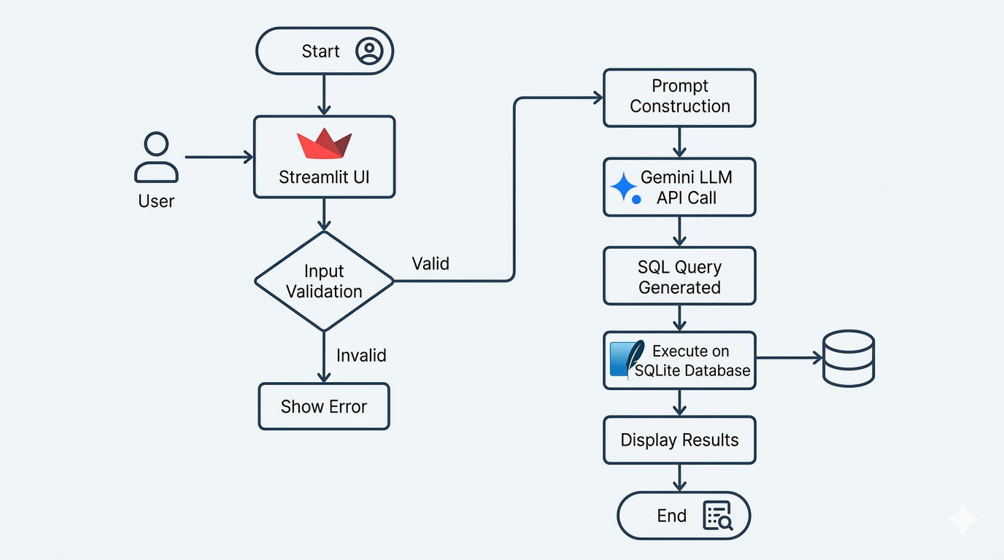
Flow Representation

This structured workflow enables IntelliSQL to convert natural language queries into executable SQL statements and display results instantly in a user-friendly interface.
Dataset
IntelliSQL does not require a traditional machine learning training dataset like classification or prediction-based ML projects.
Since the application uses Google’s Gemini Large Language Model (LLM), the model is already pre-trained by Google on large-scale text data. The project focuses on integrating and utilizing this pre-trained model rather than training a new one.

🔹 Key Points
- No custom training dataset is required for the AI model.
- The Gemini model is pre-trained on:
  - Books
  - Research articles
  - Web content
  - Programming documentation
  - Multilingual text corpora
- The system works using real-time user input.
- SQL queries are generated dynamically based on prompt instructions.
- The project focuses on Natural Language to SQL conversion using API integration.

🔹 Database Used in IntelliSQL
Although no dataset is used for training the AI model, IntelliSQL uses a structured SQLite database for demonstration purposes.
The project includes:
- A predefined table (e.g., STUDENT table)
- Structured records inserted manually
- Sample data used for query execution
Example schema:
STUDENT(NAME, CLASS, SECTION, MARKS)
This database acts as the data source on which the AI-generated SQL queries are executed.

Implementation Steps
Below are the main steps followed to implement the TransLingua project:
Step 1: Create Project Folder
Create a folder named:
TransLingua/
Inside it, create:
translang.py
requirements.txt

Step 2: Install Required Libraries
Install necessary packages:
pip install streamlit google-generativeai python-dotenv
Add them in requirements.txt:
streamlit
google-generativeai
python-dotenv
Step 3: Generate API Key
- Go to Google AI Studio.
- Click on “Get API Key”.
- Create API key.
- Copy the key.
- Store it securely in .env file.
Step 4: Configure the API
Import necessary libraries:
import streamlit as st
import google.generativeai as genai
import os
from dotenv import load_dotenv
Load and configure API key:
load_dotenv()
genai.configure(api_key=os.getenv("GOOGLE_API_KEY"))
Step 5: Initialize the Model
model = genai.GenerativeModel("gemini-1.5-flash")
Step 6: Create Translation Function
def translate_text(text, source_language, target_language):
prompt = f"Translate the following text from {source_language} to {target_language}: {text}"
response = model.generate_content(prompt)
return response.text
Step 7: Build Streamlit UI
- Add text input field
- Add language dropdown menus
- Add translate button
- Display translated result
Step 8: Run the Application
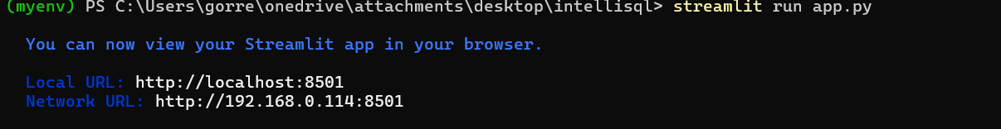
Open terminal and run:
streamlit run app.py
The application opens in the browser at:
Local URL:
http://localhost:8501
Network URL:
http://192.168.0.100:8501

🔧 Backend Logic (app.py)
- Load environment variables and configure Google API key.
- Initialize Gemini model (gemini-1.5-flash or gemini-2.5-flash).
- Create Natural Language to SQL conversion function using generate_content().
- Construct structured prompt including database schema.
- Receive SQL query generated by Gemini model.
- Connect to SQLite database (data.db).
- Execute generated SQL query safely.
- Fetch query results.
- Handle errors (invalid query, empty input, database issues).
- Display generated SQL query and results in Streamlit UI.

📦 Deliverables
- Streamlit Application: app.py
- Database File: data.db
- Database Setup Script: sql.py
- Environment Configuration File: .env
- requirements.txt
- Functional Natural Language to SQL Query System

OUTPUT :
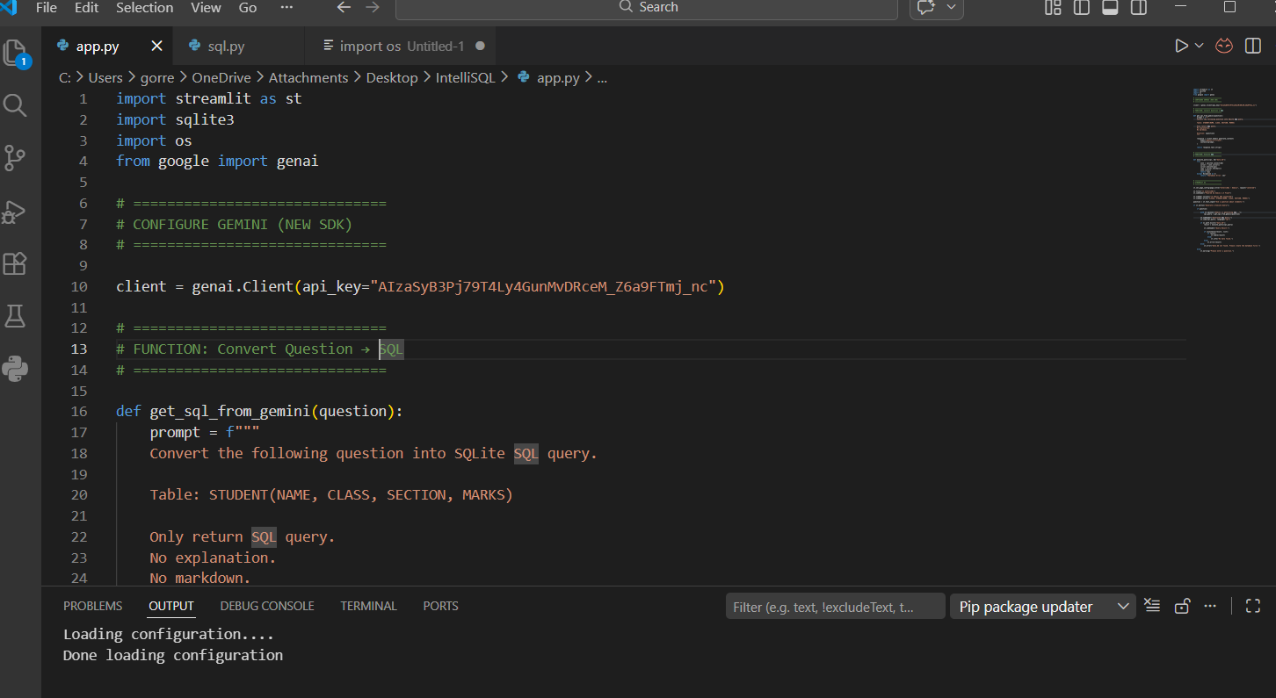
Now, the application will open in the web browser,
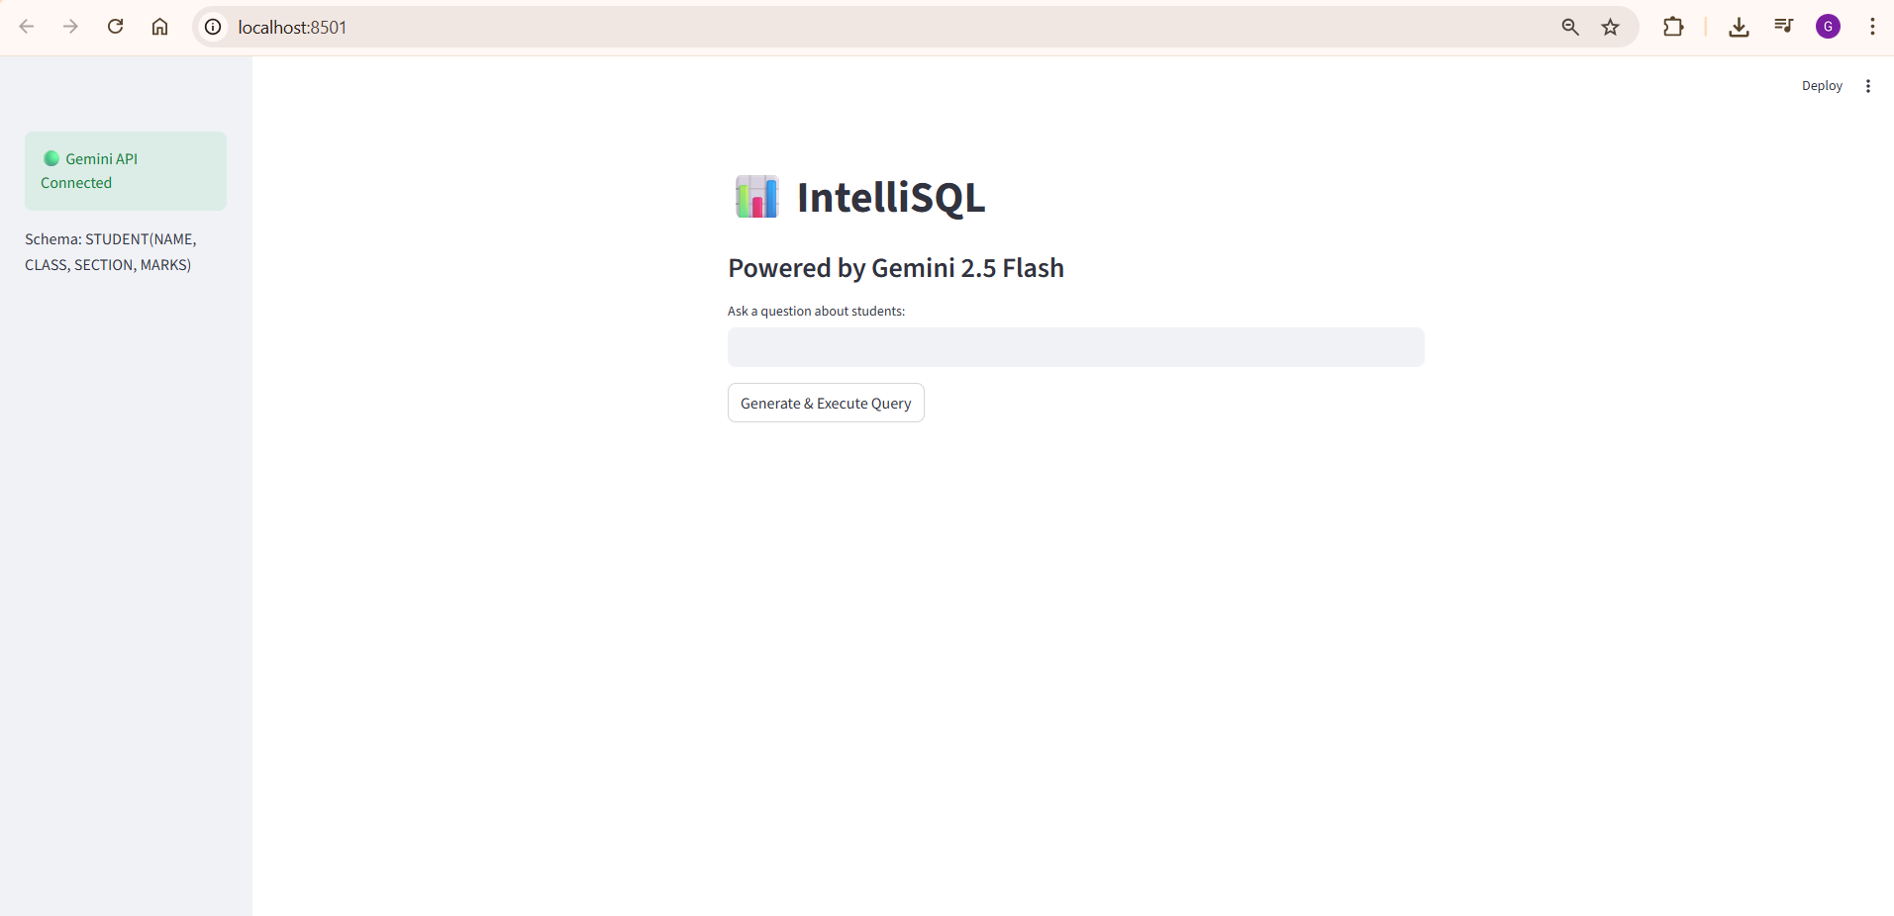
Home page

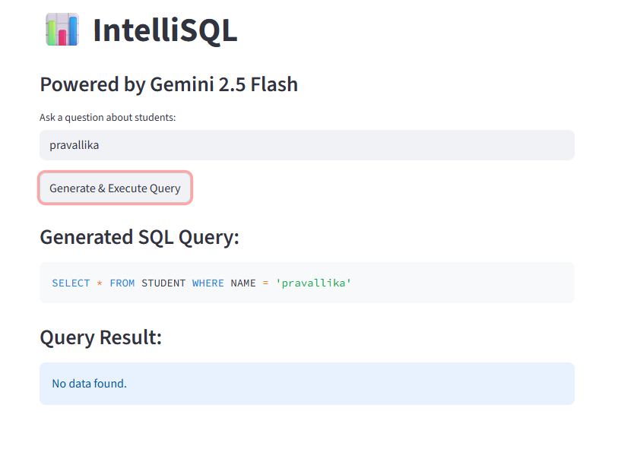
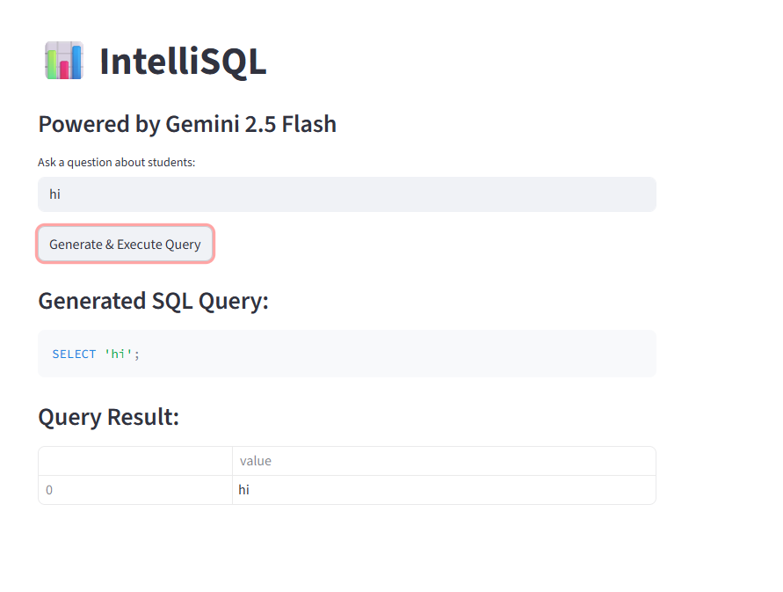

Example code:
app.py (IntelliSQL)
import streamlit as st
import google.generativeai as genai
import sqlite3
from dotenv import load_dotenv
import os
# -------------------------
# Load API Key
# -------------------------
load_dotenv()
genai.configure(api_key=os.getenv("GOOGLE_API_KEY"))
model = genai.GenerativeModel("gemini-1.5-flash")
# -------------------------
# Database Connection
# -------------------------
def get_connection():
conn = sqlite3.connect("data.db")
return conn
# -------------------------
# Function: Convert NL to SQL
# -------------------------
def generate_sql_query(user_input):
prompt = f"""
You are an expert SQL assistant.
Convert the following natural language query into a valid SQLite SQL query.
Only return the SQL query without explanation.
Database Table: Students
Columns:
name TEXT
class TEXT
marks INTEGER
company TEXT
User Question: {user_input}
"""
response = model.generate_content(prompt)
return response.text.strip()
# -------------------------
# Function: Execute SQL Query
# -------------------------
def execute_query(sql_query):
conn = get_connection()
cursor = conn.cursor()
try:
cursor.execute(sql_query)
rows = cursor.fetchall()
conn.commit()
conn.close()
return rows
except Exception as e:
conn.close()
return f"Error: {e}"
# -------------------------
# Streamlit UI Configuration
# -------------------------
st.set_page_config(
page_title="IntelliSQL",
page_icon="💡",
layout="wide"
)
st.title("💡 IntelliSQL")
st.write("AI-Powered Natural Language to SQL Query System")
# -------------------------
# User Input
# -------------------------
user_input = st.text_area("Enter your database question:")
if st.button("Generate & Execute Query"):
if user_input.strip() == "":
st.warning("Please enter a question.")
else:
with st.spinner("Generating SQL Query..."):
sql_query = generate_sql_query(user_input)
st.subheader("Generated SQL Query:")
st.code(sql_query, language="sql")
with st.spinner("Executing Query..."):
result = execute_query(sql_query)
st.subheader("Query Result:")
st.write(result)
st.markdown("---")
st.caption("Built using Gemini + Streamlit + SQLite 🚀")

sql.py (Database Creation File)
import sqlite3
conn = sqlite3.connect("data.db")
cursor = conn.cursor()
# Create Table
cursor.execute("""
CREATE TABLE IF NOT EXISTS Students (
name TEXT,
class TEXT,
marks INTEGER,
company TEXT
)
""")
# Insert Sample Data
cursor.execute("INSERT INTO Students VALUES ('Sijo', 'BTech', 75, 'JSW')")
cursor.execute("INSERT INTO Students VALUES ('Arun', 'BSc', 82, 'Infosys')")
cursor.execute("INSERT INTO Students VALUES ('Meena', 'BTech', 90, 'TCS')")
cursor.execute("INSERT INTO Students VALUES ('Ravi', 'BCom', 65, 'Wipro')")
conn.commit()
conn.close()
print("Database Created Successfully!")

requirements.txt
streamlit
google-generativeai
python-dotenv
▶️ Run the Project
Step 1: Create Database
python sql.py
Step 2: Run Application
streamlit run app.py
It will open in browser:
http://localhost:8501
Conclusion
The IntelliSQL project was successfully developed as an AI-powered Natural Language to SQL Query web application using Streamlit, SQLite, and Google’s Gemini model. The system enables users to interact with databases using simple natural language instead of writing complex SQL queries manually.
By leveraging a pre-trained Large Language Model, IntelliSQL intelligently converts user questions into accurate SQL statements. This eliminates the need for deep technical knowledge of SQL syntax and reduces errors in query writing. The system dynamically generates queries, executes them on the database, and displays results instantly through a clean and user-friendly interface.
This project demonstrates how Artificial Intelligence can simplify database interaction and make data retrieval more accessible to non-technical users. IntelliSQL acts as a bridge between human language and structured database systems.
In the future, IntelliSQL can be enhanced with features such as:
- Support for multiple database systems (MySQL, PostgreSQL)
- Query explanation and visualization
- Role-based access control
- Cloud deployment for large-scale usage
- Integration with enterprise data systems

